Civil war in Liberia

UNSC Resolution: | 1509
Date of adoption: | 19-Sep-2003
Operative paragraph: | 4
Demand number: | 1509,0411
Sarah-Myriam Martin-Brûlé

Wording of demand

cease hostilities throughout Liberia and fulfill their obligations under the Comprehensive Peace Agreement and the ceasefire agreement, including cooperation in the formation of the JMC as established under the ceasefire agreement

List of addressees of the demand

Government of Liberia, Movement for Democracy in Liberia, Liberians United for Reconciliation and Democracy

Short-term compliance

Description of the addressee(s)’ conduct

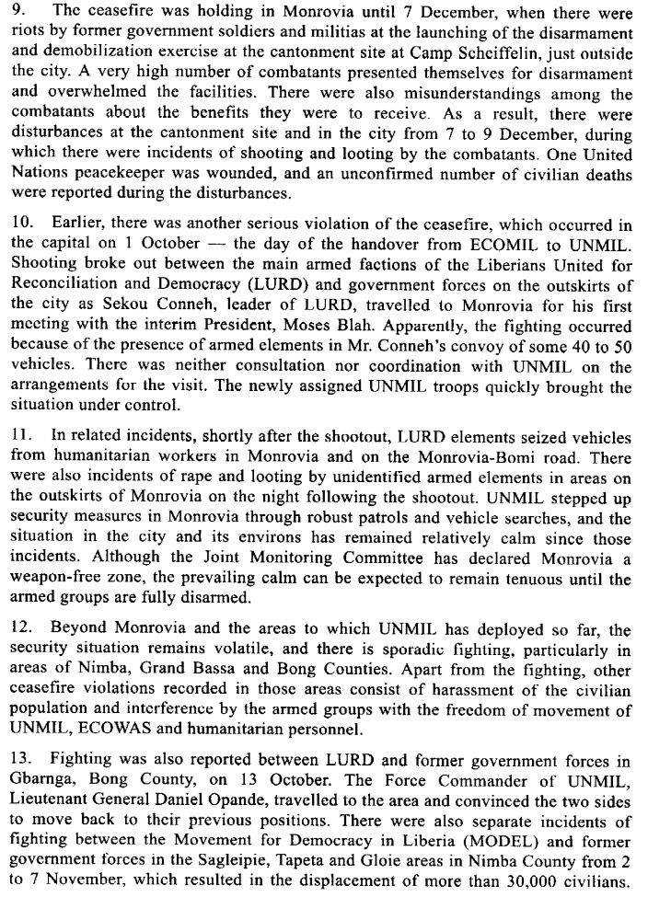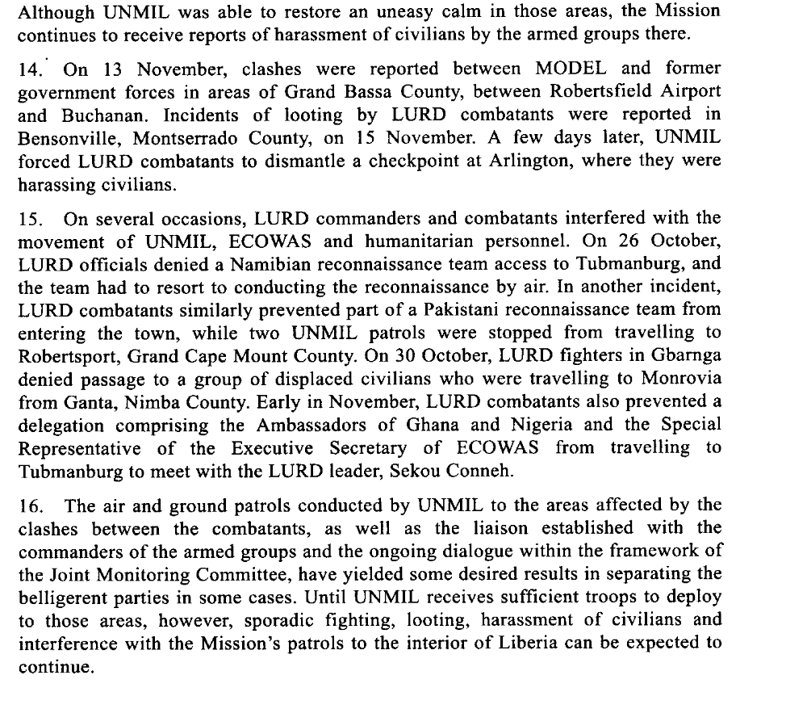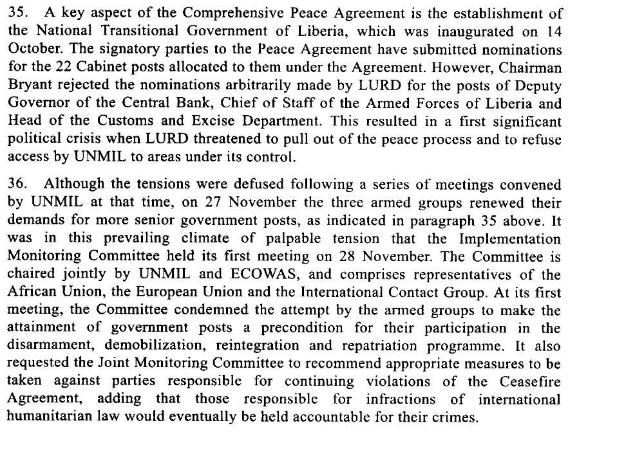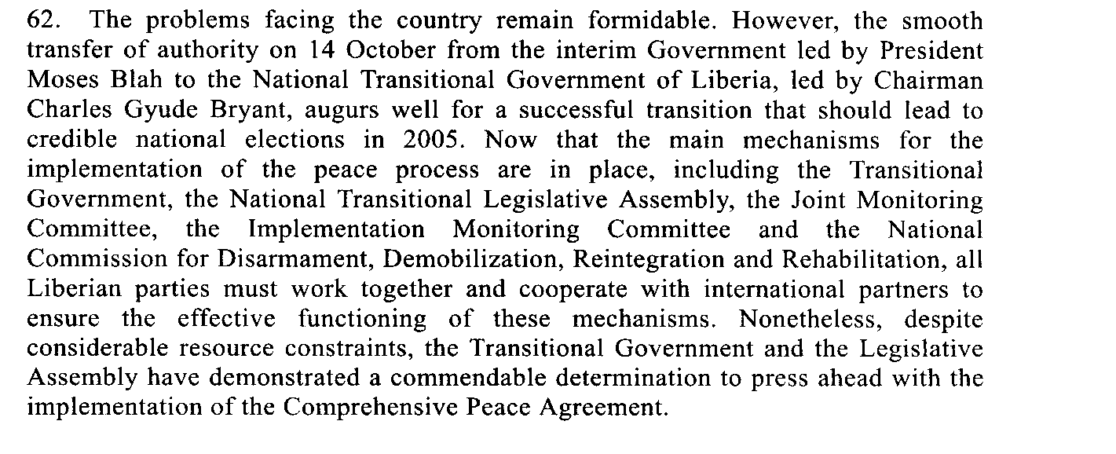First Progress Report of the Secretary-General on the United Nations Mission in Liberia, 15 December 2003

Assessment

Short-term compliance
No or marginal compliance (1) | X Medium low compliance (2) | Medium high compliance (3) | Full or almost full compliance (4)

Considerations underlying the assessment

The demand addressees did not cease hostilities throughout Liberia and only partially fulfill their obligations under the Comprehensive Peace Agreement and the ceasefire agreement, including cooperation in the formation of the JMC as established under the ceasefire agreement.

Medium-term compliance

Description of the addressee(s)’ conduct

6. During the period under review, there was general compliance with the ceasefire in Monrovia and in most parts of the country. Security in areas to which UNMIL has deployed has improved and the ban on the public display of arms in those areas is being respected by the armed groups. A number of minor ceasefire violations by all three armed groups were reported outside the capital. These included maintenance of illegal checkpoints and sporadic shooting incidents among LURD combatants on 11 and 16 January in Gbarnga and Voinjama respectively. The latter incidents were reportedly related to the leadership struggle within LURD. Several shots were also fired during a reported dispute between several members of the Movement for Democracy in Liberia (MODEL) in Buchanan.
Second Progress Report of the Secretary-General on the United Nations Mission in Liberia, S/2004/229, 22 March 2004.

6. The overall security situation in Liberia remained calm during the reporting period, although there were a few minor skirmishes and incidents, primarily related to the protracted intra-faction dispute within LURD. The ceasefire established pursuant to the 17 June 2003 Agreement has generally continued to hold. Disarmament is nearing completion and UNMIL has continued searches aimed at curbing the illegal movement of weapons and ammunition across the country. In July, a large quantity of arms and ammunition was confiscated during checkpoint and search-and-seizure operations in central Liberia. UNMIL is also continuing to conduct regular land and air patrols to monitor the situation along the borders.
8. The ceasefire established pursuant to the 17 June 2003 Ceasefire Agreement is largely holding. Following the deployment of UNMIL troops in all counties, no major skirmishes have been reported between the armed groups. However, the security situation remains fragile, mainly because the disarmament process is yet to be completed. In addition, intra-faction disputes, particularly within LURD, continued to create tension and at times resulted in shooting incidents in some areas. Furthermore, although a National Transitional Government of Liberia programme for distributing food to combatants who are awaiting disarmament has helped to reduce incidents of looting and harassment of civilians by combatants foraging for food, several looting incidents were reported, and combatants in some areas continued to erect checkpoints, which have been routinely removed by UNMIL patrols.”
9. Although there have been no major skirmishes between the armed groups, the protracted intra-faction disputes within LURD continue to create tension and still pose a threat to the steady progress being made in the peace process. The internal divisions worsened on 3 June, when the so-called LURD “Military High Command”, loyal to Aisha Conneh announced the suspension of Sekou Damate Conneh as Chairman of the group, a move which Sekou Damate Conneh, who was in Senegal at the time, quickly rejected. In early June, the LURD National Executive Council named Chayee Doe as Sekou Damate Conneh’s successor. However, Doe died shortly thereafter while undergoing surgery abroad. Kabineh Jan’eh, Minister of Justice in the National Transitional Government of Liberia, was subsequently declared the Acting Chairman of LURD, and, on 27 July, he was declared its Chairman, following an election conducted by some LURD elements.
10. The divisions within LURD have resulted in incidents outside the homes of several of its leaders, which have involved seizure of vehicles, kidnappings and also shootings. On 2 August, confrontations erupted between opposing elements when a group which does not support Sekou Conneh stole a car from a Conneh loyalist. On 3 August, several LURD ex-combatants attacked the houses of the Minister of Justice and of a former LURD military commander. Both incidents were brought under control with the assistance of UNMIL formed police units and troops. Sekou Conneh’s return to Monrovia on 4 August further heightened the growing tensions. On 4 August, the Force Commander of UNMIL held separate meetings with representatives of both factions within LURD at which he warned them against inciting their followers to violence and indicated that UNMIL would take firm action to quell any disturbances. UNMIL has continued to engage in dialogue with the opposing LURD elements.
Third progress report of the Secretary-General on the United Nations Mission in Liberia, 26 May 2004, S/2004/430

27. Some progress has been made towards the restoration of State authority throughout the country. The national Task Force for the Restoration of State Authority in the Ministry of Internal Affairs, in collaboration with UNMIL, has developed and begun implementing a programme for the re-establishment of State authority nationwide. The membership of the task force was recently widened to include representatives of the National Transitional Government of Liberia and the National Transitional Legislative Assembly. This followed the decision by the Legislative Assembly to delay the consideration and confirmation of new superintendents and assistant development superintendents nominated in July by Chairman Bryant for five counties, on the basis that the Assembly had not been consulted by the Executive. In view of the Assembly’s objections, coupled with protests from county-level leaders, Chairman Bryant withdrew the nominees and requested the Minister of Internal Affairs to undertake a process whereby county level committees would recommend three candidates for a superintendent position, from among whom the Chairman would select one nominee.
28. Encouraging progress has been made in strengthening the presence of government officials at the borders. On 8 August, UNMIL assisted in the deployment of officials from the Bureau of Immigration and Naturalization to Bo Waterside and Ganta, which are main crossing points on the border with Sierra Leone and Guinea, respectively. UNMIL also assisted in the deployment of immigration and customs officials to Voinjama and Loguatuo. Additionally, the Bureau of Internal Revenue has deployed 107 out of a projected 350 revenue collectors, to locations including Kakata, Marshall, Bensonville, Buchanan, Gbarnga, Salala, Robertsport, Saniquelle and Ganta. Planning is also under way to restore postal services and establish banks in some of these towns. While the deployments of governmental officials is a welcome development, the lack of adequate office facilities, equipment and other logistical support continues to seriously hamper their ability to function effectively.
Fourth progress report of the Secretary-General on the United Nations Mission in Liberia, 10 September 2004, S/2004/725

5. There has been general respect for and maintenance of the ceasefire in Monrovia and other parts of the country since December 2003, although a number of minor ceasefire violations perpetrated by elements of all three armed groups have been reported outside the capital. For instance, there were incidents of sporadic shooting among Liberians United for Reconciliation and Democracy (LURD) combatants in Gbarnga and Voinjama on 11 and 16 January respectively, in Tubmanburg on 30 March and again in Gbarnga on 8, 9 and 11 April. Those incidents were reportedly related to the leadership struggle within LURD between Sekou Damate Conneh and his estranged wife, Aisha Keita Conneh. On 20 March, elements from the Movement for Democracy in Liberia (MODEL) fired into the air and looted a number of shops and houses in Buchanan during a violent confrontation between a crowd of civilians and MODEL combatants.
6. There have been some reports of harassment of civilians, including criminal activities, extortion and looting, by elements of all three armed factions. UNMIL expects that such incidents, including ceasefire violations, will decrease as the disarmament, demobilization, rehabilitation and reintegration programme progresses throughout the country.
Report of the Secretary-General pursuant to Security Council resolution 1521 (2003) regarding Liberia, 26 May, S/2004/428

Assessment

Medium-term compliance
No or marginal compliance (1) | Medium low compliance (2) | X Medium high compliance (3) | Full or almost full compliance (4)

Considerations underlying the assessment

The demand addressees significantly reduced hostilities throughout Liberia and fulfilled most of their obligations under the Comprehensive Peace Agreement and the ceasefire agreement, including cooperation in the formation of the JMC as established under the ceasefire agreement.

Depth of demand

Assessment

Level of depth of demand
Low depth of demand (1) | X Medium depth of demand (2) | High depth of demand (3)

Considerations underlying the assessment

Compliance with this demand impacted on the demand addressees to win power in the long term.

Level of confidence about coding decisions

Level of confidence about coding decision
Extremely high | High | X Moderate

Comments to IPI (if any)

